Database Systems – CS 2005

Instructor: Miss Eman Shahid – 5H

Group Members:

* Anusha Saad 19K-0281  
  - Saman Khan 19K-0354  
  - Hermain Qadir 19K-1517

PROJECT REPORT

Car Rental and Accommodation System

# **Introduction**

A database management system (DBMS) refers to the technology for creating and managing databases. Basically, DBMS is a software tool to organize (create, retrieve, update and manage) data in a database.

The main aim of a DBMS is to supply a way to store up and retrieve database information that is both convenient and efficient. By data, we mean fact that are known and can be recorded with embedded meaning.

Our project, car rental and accommodation system, aims to digitalize the system that is otherwise manual. It is a project with immense scope and can be worked upon further to launch it.

# **Problem Statement**

In today’s world, every task from as small as grocery shopping to as complex as education is performed online. Renting cars for trips and renting airbnbs is also a task that can efficiently be done online. Our website, iRent, will cater to the severe need of AirBnBs and such a service of car rental because of the absence of such a system in place before. With services like Uber/Careem and hotels being expensive, such a system is really a need of time. This triggered our goal of working on this project and developing a fully functional website to eradicate the problems associated with this stream

# **Methodology**

In today’s world, every task from as small as grocery shopping to as complex as education is performed online. Renting cars for trips and renting airbnbs is also a task that can efficiently be done online. Our website, iRent, will cater to the severe need of AirBnBs and such a service of car rental because of the absence of such a system in place before. With services like Uber/Careem and hotels being expensive, such a system is really a need of time. This triggered our goal of working on this project and developing a fully functional website to eradicate the problems associated with this stream.

## **Functionalities**

The website will serve two main purposes, i.e. enabling people to make reservations of car(s) for trips and also reserve AirBnBs while visiting cities of Pakistan. AirBnB serve basically means that a customer can rent out an apartment, room or even a house when travelling to some other city. Airbnb expansion is the increased supply of travel accommodations, which could benefit travelers by making travel more affordable. There is evidence that Airbnb increases the supply of short-term travel accommodations and slightly lower prices. Moreover, people can rent out cars for any personal, family, or professional trips wherever they want. The system will keep detailed records of the customers, cars, AirBnBs under the banner along with records of bookings, owners of cars/AirBnBs. The customer can make and/or cancel bookings anytime.

Admin can perform the following operations after logging in,

* Add a car information to the table
* Add an AirBnb information to the database
* Delete a car/Airbnb information from the database
* Update an existing car/Airbnb’s record from the database.

A customer/user can perform the following operations:

* Search for cars by model, colour, price.
* Search for Airbnb’s based on location, price, no_of_rooms
* Book a car/Airbnb by entering his/her details
* Update/modify his booking days
* Cancel a booking that’s been made previously.
* Sign up/register to become a member

## **Entity Relationship Diagram**

The following entity relationship diagram highlights all the entities used and worked on in the creation of this project. The relationships and cardinalities are also included.

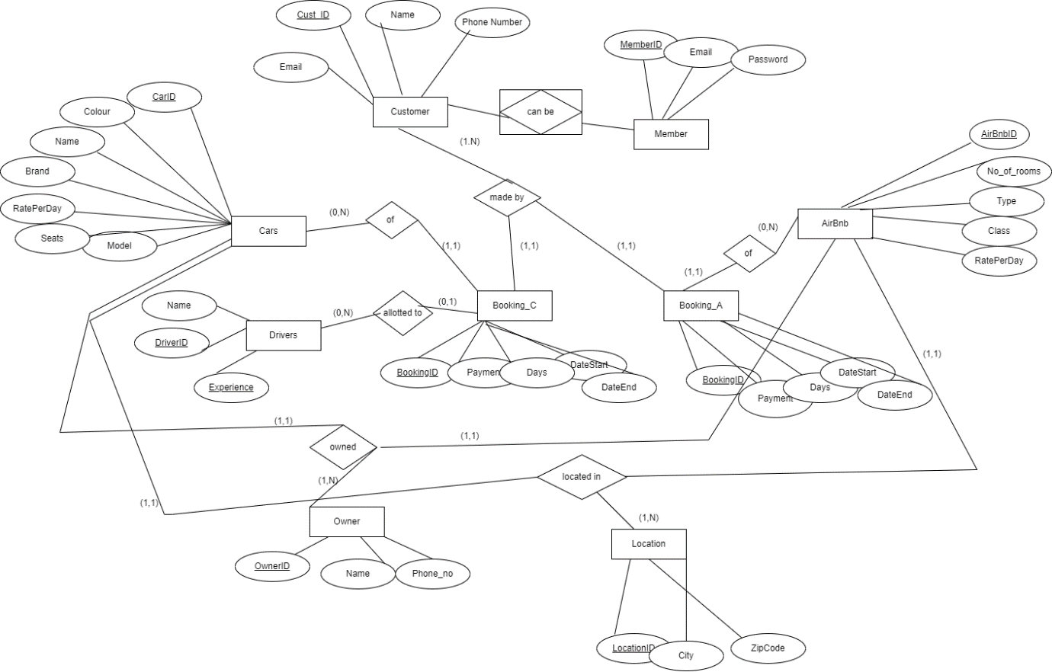

## **Normalized Relations**

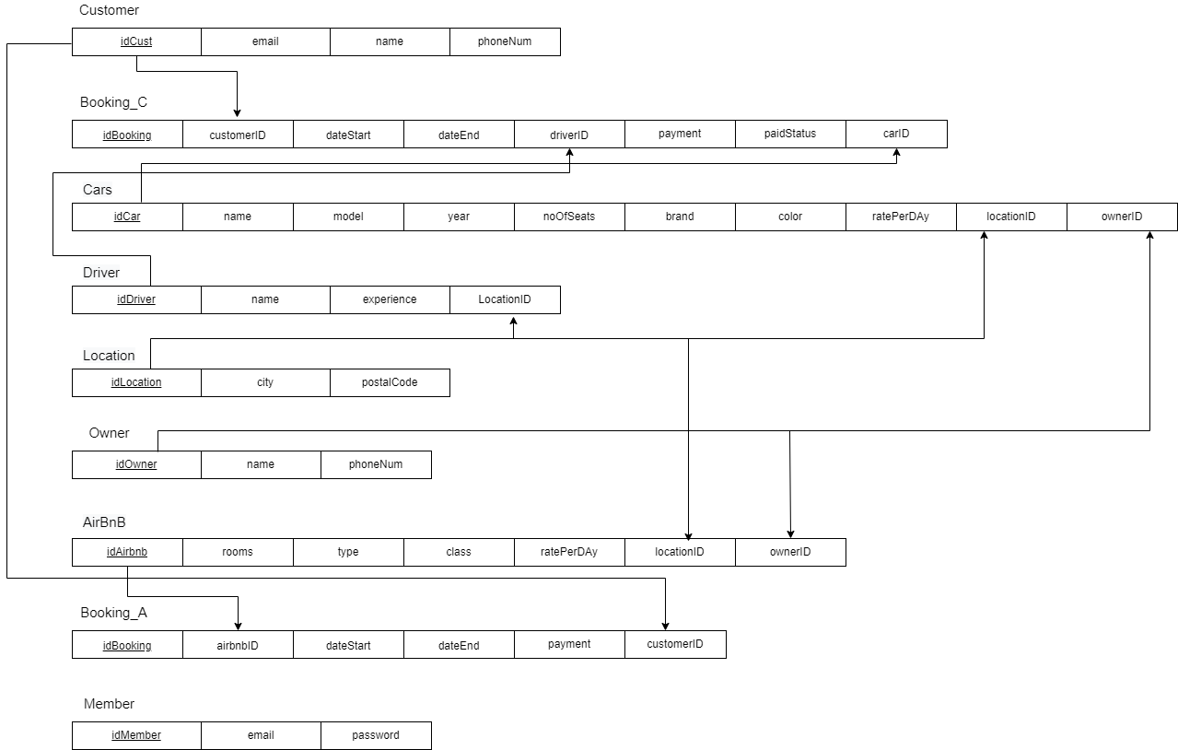

# It can be concluded from the above figure that each table has only one primary key, and all other attributes are only identified by that primary key, that is, there is no transitive dependency in any relation. Therefore, we can conclude that the relations are already in 3NF. Since the relations are in 3NF, it means they’re already in 1NF and 2NF.

# **Tools and Technologies**

## **Front End:**

HTML, CSS are utilized to implement the frontend. The editor we used to implement the code is  
Visual Studio Code.

* HTML (Hyper Text Mark-Up Language):

HTML was a syntax used to format the text documents on the web.

* CSS (Cascading Style Sheets):

CSS is a style sheet that we used to describe the look and formatting the documents written in HTML

* React JS

## **Back End:**

Back End was implemented using Nodejs and Express.

* Node js

Node js is an open-source, server framework that is used to implement backend development of applications.

* Express
* MySQL

The database of the system application has been designed and implemented on MySQL workbench.

## **Miscellaneous:**

* **Operating System:** Windows 10
* **Network Environment:** Internet and LAN
* **Hardware Platform:** PCs and Laptops
* Client/Server system

# **Task Distribution**

The three of us divided the modules amongst ourselves and mostly implemented the frontend and backend together to prevent miscoordination and connected between backend and frontend.

# **Conclusion**

Since we are entering details of customers and their respective bookings electronically in the the system, data will be secured. Using this system, we can retrieve booking/customer’s information with just few clicks. Thus, processing information will be faster and it guarantees accurate maintenance of data. Moreover, it easily reduces the book keeping task and thus reduces the human efforts.